FitBuddy – An AI-Powered Fitness Plan Generator Built with
Gemini Models

Team leader:
Niranjan K
Members:
Sathish s
Naren S
Reegan G

Project Description:

AI Fitness Plan Generator Using Gemini Models is a web-based application that uses Artificial Intelligence to create personalized workout plans and nutrition tips according to a user’s fitness goals. The system supports goals such as weight loss, muscle gain, and general wellness. Developed with FastAPI and integrated with Google’s Gemini AI models, the application makes it simple to generate structured and effective fitness routines.

The system collects important user details, including age, weight, fitness goal, and preferred workout intensity. Based on the provided information, Gemini AI generates a personalized 7-day fitness plan. Users can also provide feedback on their generated plan, and the AI uses this feedback to update and improve the plan. In addition, the application provides a suitable nutrition or recovery tip based on the user’s selected fitness goal.

The application provides a clean and user-friendly interface for easy interaction. With SQLite database support, user information and generated fitness plans are stored securely and can be accessed when required. The system also provides API endpoints along with an interactive HTML interface, making the application convenient and flexible to use.

Scenarios:

Scenario 1: A user enters their personal information, including name, age, weight, fitness goal (such as “weight loss” or “muscle gain”), and preferred workout intensity (“high”, “medium”, or “low”). Based on these details, the system generates a personalized 7-day workout plan. The plan provides a day-by-day schedule designed according to the user’s fitness objective and experience level. This AI-based personalization helps users remain motivated and follow structured routines that match their specific goals.

Scenario 2: A user provides feedback about their existing workout plan by requesting changes, such as “add more cardio” or “include additional rest days.” The system processes the feedback and uses AI to generate an updated workout plan that reflects the user’s changing requirements. This continuous feedback process keeps the fitness plan flexible and helps users receive appropriate support as their preferences and progress develop.

Scenario 3: A user requests a nutrition or recovery tip related to their chosen fitness goal. The platform provides a short and relevant recommendation, such as “Include protein in your post-workout meal” for a muscle-gain goal. These personalized tips support the workout plan by helping users maintain suitable nutrition and recovery practices alongside their physical training.

Scenario 4: An admin or coach logs into the platform and accesses a dedicated dashboard to view the registered users and their generated workout plans. This dashboard provides a centralized view of individual user information and fitness plans, allowing the admin or coach to monitor user progress and compare workout plans when required.
original and updated plans, and monitor user activity. It streamlines oversight for trainers managing multiple clients or students.

Technical Architecture:

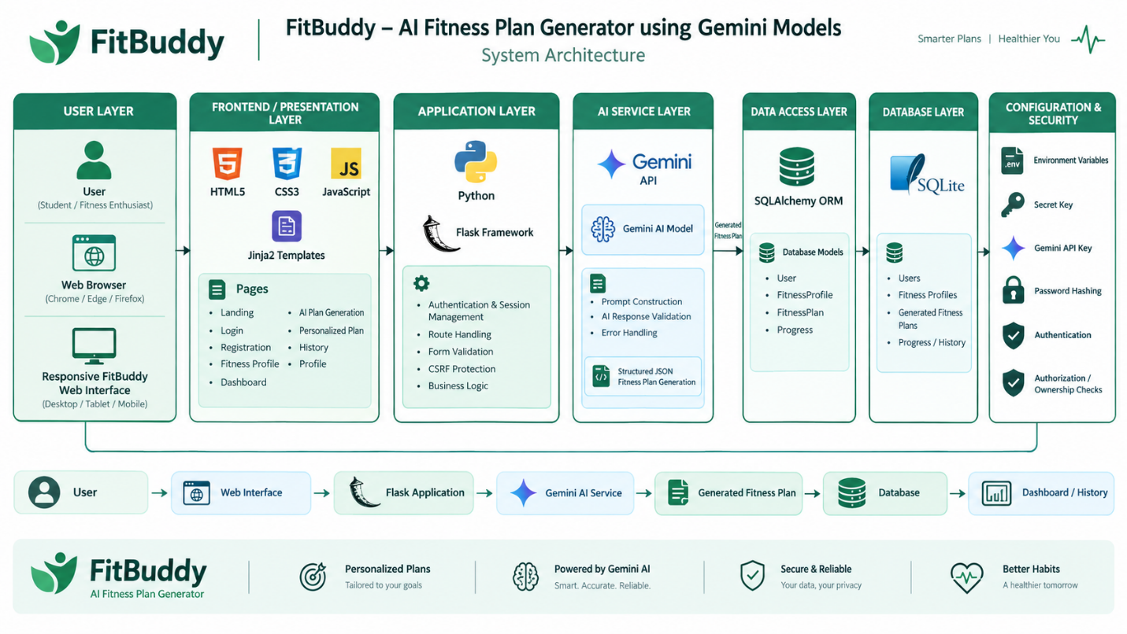

Prerequisites
- FastAPI – Understand how to build APIs using the FastAPI framework. Reference: FastAPI Documentation
- Gemini API – Be familiar with Google's Generative AI tools and how to work with the Gemini API. Reference: Google Generative AI Documentation
- HTML, CSS & Jinja2 – Have working knowledge of front-end markup, styling, and Jinja2 templating for rendering dynamic pages. Reference: W3Schools Tutorials
- Python – Be proficient in core Python programming concepts. Reference: Python Official Docs
- Git – Know how to use Git for version control (commits, branches, pushing/pulling). Reference: Git Documentation
- SQLAlchemy & SQLite – Have a basic understanding of using SQLAlchemy as an ORM with SQLite databases.
- Environment Setup – Be able to set up isolated Python environments using pip, virtualenv, or conda. Reference: Virtualenv Guide
- Uvicorn – Know how to run and configure the Uvicorn ASGI server for serving your application. Reference: Uvicorn Docs
Project Workflow
Milestone 1: Model Selection and Architecture
- Activity 1.1 – Research available generative AI models and choose the one best suited for the project.
- Activity 1.2 – Design and define the overall architecture of the application.
- Activity 1.3 – Configure and prepare the development environment.
Milestone 2: Core Functionality Development
- Activity 2.1 – Build out the core features and functionalities of the application.
- Activity 2.2 – Set up the FastAPI backend to handle request routing and process user input.
Milestone 3: routes.py Development
- Activity 3.1 – Write the primary application logic within the routes.py file.
Milestone 4: Frontend Development
- Activity 4.1 – Plan and build the user interface for the application.
- Activity 4.2 – Build dynamic, data-driven templates using FastAPI's Jinja2 integration.
Milestone 5: Deployment
- Activity 5.1 – Get the application ready for deployment on a local environment.
- Activity 5.2 – Test and confirm that the local deployment works as expected.

Milestone 1. Model selection and Architecture
This milestone centers on identifying the most suitable generative AI model(s) from Google's Gemini family to power the FitBuddy application. It involves assessing the performance and capabilities of several Gemini models to confirm they meet the application's key requirements — including the ability to generate personalized workout plans, adjust those plans based on user feedback, and offer customized nutrition and recovery recommendations.
Activity 1.1: Research and Select the Appropriate Generative AI Model
Understanding the Project Requirements
The AI model powering FitBuddy needed to be capable of the following:
● Generating well-structured 7-day workout plans
● Offering short, practical nutrition guidance
● Modifying workout plans in response to user feedback
● Delivering strong performance for real-time, web-based interactions
Evaluating the Models
To start, we tested a range of models from Hugging Face:
● T5 and BART – Used for generating text such as workout routines and nutrition suggestions
● DistilBERT – Explored for classifying user intent
● Bloom – Used as a general-purpose text generation model
Although these models demonstrated some capability in basic text generation, they came with significant drawbacks. Specifically, they demanded:
● Deployment through Hugging Face or a local GPU environment
● Extensive fine-tuning or intricate prompt engineering to produce properly structured outputs
Final Model Selection
Following comparative testing, we opted to move forward with Google's Gemini models for the production environment:
● Gemini 1.5 Pro
→ Applied for generating structured 7-day workout plans and revising them as needed
→ Consistently produces detailed, context-aware, well-formatted output
● Gemini Flash
→ Applied for producing quick, practical nutrition tips
→ Lightweight and efficient, making it well-suited for rapid API calls
Why We Chose Gemini:
● Accessible via API, making integration with FastAPI straightforward
● Handles structured formatting (such as days and sections) intuitively
● Achieves high accuracy without requiring extensive prompt tuning
● Fast and scalable, supporting quick revisions based on user feedback

Activity 1.2: Define the Architecture of the Application
Architecture Overview
FitBuddy is built on a modular, FastAPI-driven architecture consisting of the following layers:
● Frontend – HTML combined with Jinja2 templates, used for capturing user input and displaying results
● Backend – FastAPI, responsible for handling routes and core application logic
● AI Layer – Google Gemini APIs (both Pro and Flash variants)
● Database – SQLite, managed through SQLAlchemy, for storing persistent data
Frontend Responsibilities
Users interact with the application through the following pages:
● index.html – Serves as the input form
● result.html – Displays the generated plan, nutrition tip, and feedback options
● all_users.html – Functions as the admin panel
Backend Responsibilities
The backend is responsible for:
● Receiving submitted form data
● Making calls to the Gemini models
● Storing user details and generated plans
● Rendering the dynamic templates
AI Integration Points
● Gemini Pro – Handles workout plan generation and feedback-based updates
● Gemini Flash – Handles the generation of nutrition tips

Activity 1.3 Set up the development Environment:
Install Python and Pip
Confirm that both Python and pip are installed on your system.
Create a Virtual Environment
python -m venv fitbuddy-env
fitbuddy-env\Scripts\activate (Windows)
Install the Required Libraries
pip install fastapi uvicorn jinja2 sqlalchemy python-multipart google-generativeai
Run the Server
uvicorn app.main:app --reload
Once running, open the application to access it, and visit /docs to test the API endpoints.
Set Up the Project Structure
Create the following folders:
- /app – for Python files
- /templates – for HTML files
- /static/images – for static assets

FitBuddy – Project Directory Structure
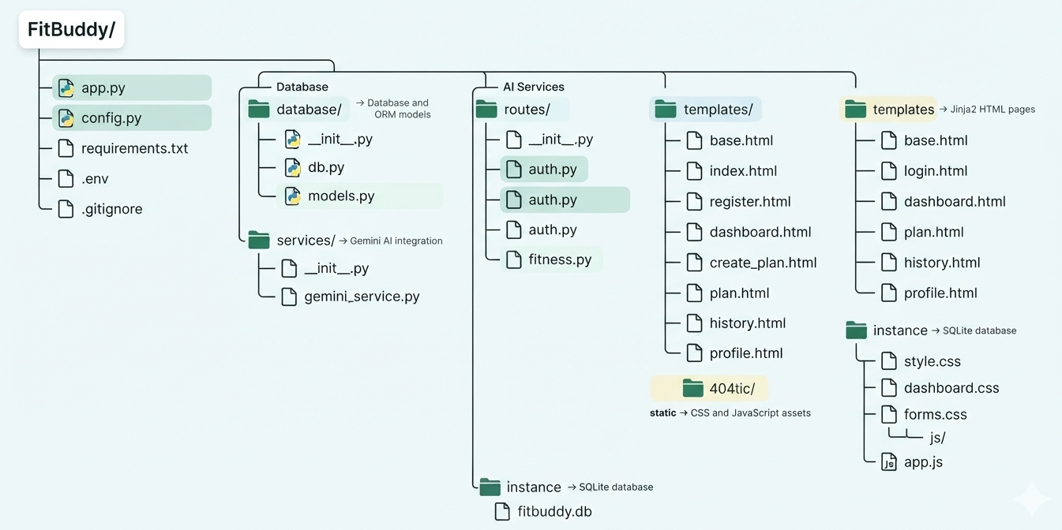

Milestone 2. Core functionalities Development
Activity 2.1 Develop the core functionalities:

Workout Plan Generation
Description:This code defines the create_app() function for the FitBuddy Flask application. It creates and configures the Flask app by setting the template and static folders, and loads the application configuration from the Config object. It also checks whether the required environment variables, SECRET_KEY and GEMINI_API_KEY, are available. If either key is missing, the program raises a RuntimeError and stops the application with a clear error message. This configuration helps FitBuddy securely manage application settings and connect with the Gemini AI model for generating personalized fitness plans.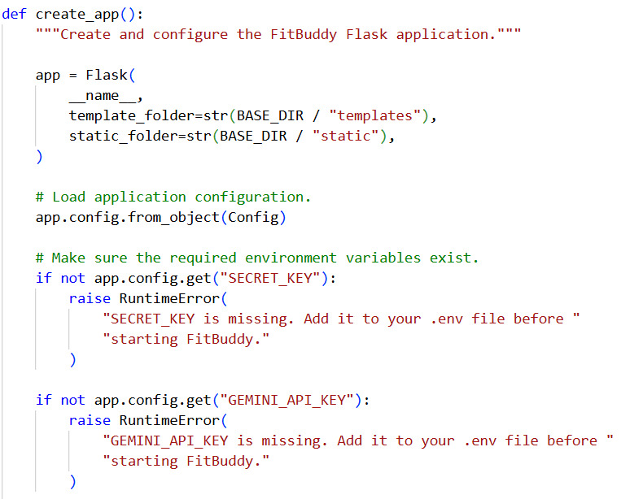
Description:This code defines the create_app() function for the FitBuddy Flask application. It creates and configures the Flask app by setting the template and static folders, and loads the application configuration from the Config object. It also checks whether the required environment variables, SECRET_KEY and GEMINI_API_KEY, are available. If either key is missing, the program raises a RuntimeError and stops the application with a clear error message. This configuration helps FitBuddy securely manage application settings and connect with the Gemini AI model for generating personalized fitness plans.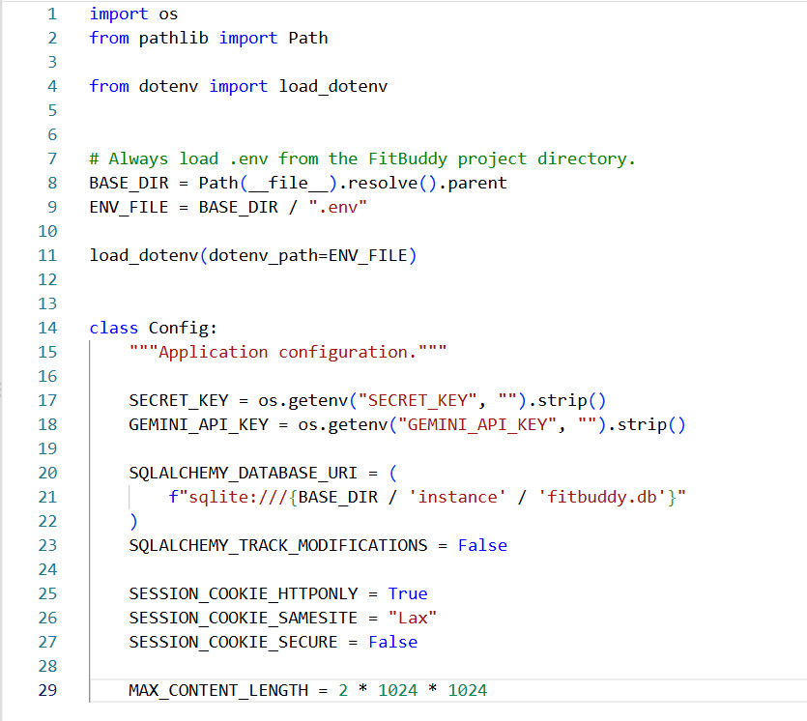

Python Dependencies for a Flask App with Gemini AI Integration
Description:This requirements.txt file lists the four packages a Python web application needs. It uses Flask (3.1 or later, below version 4) as the core web framework, with Flask-SQLAlchemy (3.1 or later, below version 4) for database access through an ORM. The google-genai library (1.40 or later, below version 2) connects the app to Google's Gemini generative AI models, and python-dotenv (1.1 or later, below version 2) loads configuration such as API keys from a .env file. Each package is pinned to a version range that allows minor updates but blocks the next major release, which helps prevent breaking changes.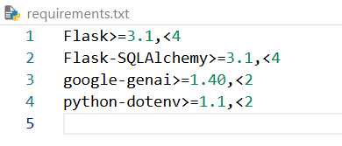
Title: Inside the FitBuddy Database
The screenshot shows the fitbuddy.db database, located in the instance folder, which is typical of a Flask application using SQLite. The database contains four tables: fitness_plans, fitness_profiles, progress, and users. At the moment, it holds very little data. The users and fitness_profiles tables each contain a single row, suggesting one registered account with a completed profile, while fitness_plans and progress are both empty. This points to an early stage of development or testing, where a user has signed up and set up a profile but hasn't yet generated a workout plan or logged any progress. The structure itself is well organized, separating user accounts, personal fitness details, personalized plans, and progress tracking into distinct tables.
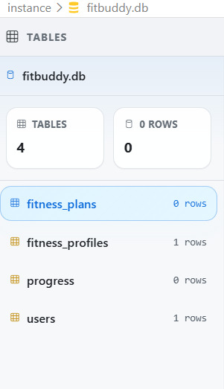

User Registration Route with CSRF Protection and Input Validation (Flask)
Description:This Flask route handles account registration at /register for both GET and POST requests. It first ensures a CSRF token exists, and on POST it validates that token, flashing a "session expired" error if it fails. It then reads the name, email, password, and confirm-password fields, trimming whitespace and lowercasing the email. It checks that the name is 2 to 100 characters, the email contains "@" and is at most 255 characters, the password is at least 8 characters, and both passwords match. If any check fails, each error is flashed and the registration page is re-rendered.

Activity 2.2: Implement the FastAPI Backend to Manage Routing and User Input Processing
Defining Routes in FastAPI
All routing logic resides in routes.py, with each route mapped to its corresponding function built during Activity 2.1.

Processing User Input
● HTML Form – Built within index.html
● Users provide the following details: username, user ID, age, weight, goal, and intensity
● FastAPI collects this input through Form(...) parameters
● Pydantic schemas (UserInput, FeedbackRequest) are used to validate the structure of the incoming data

Integrating Gemini API Calls
Each route handler connects directly with its respective Gemini-powered function:
● /generate-workout →
○ Calls generate_workout_gemini() to produce the workout plan
○ Calls generate_nutrition_tip_with_flash() to produce the nutrition tip
● /submit-feedback →
○ Retrieves the existing plan
○ Passes the original plan along with the feedback to update_workout_plan()
All AI-generated responses are returned in a clean format and injected into the frontend templates for display.

Milestone 3. routes.py Development
Milestone 3 centers on developing the routing logic within the routes.py file, which serves as the central operational hub of the FitBuddy application. It connects the frontend templates, the AI generation modules (Gemini Pro and Flash), and the SQLite database. Each route determines how user inputs are captured, processed, and responded to — enabling a dynamic, personalized experience for both fitness plan creation and feedback-driven updates.

Activity 3.1: Writing the Main Application Logic in routes.py

- Defining Core Routes in routes.py
- Individual routes were created to support each of FitBuddy's primary features:
- / – Displays the user input form via index.html
- /generate-workout – Processes the submitted input and generates a personalized workout plan
- /submit-feedback – Revises the workout plan based on the user's feedback
- /view-all-users – Displays an admin dashboard listing all users along with their plans
- Setting Up Route Handlers for Each Feature
- Home Route
● Returns the homepage (index.html)
● Contains no form-processing logic
- generate-workout – Plan Generator
● Captures user input via FastAPI's Form(...)
● Builds a UserInput Pydantic model from the input
● Calls:
○ generate_workout_gemini(...) → Produces the workout plan using Gemini 1.5 Pro
○ generate_nutrition_tip_with_flash(...) → Retrieves the nutrition tip using Gemini Flash
● Saves:
○ User details via save_user(...)
○ The generated plan via save_plan(...)
● Returns result.html populated with the dynamic data
- submit-feedback – Update Plan with Feedback
● Collects the feedback along with the user_id
● Fetches the original plan from the database
● Uses update_workout_plan(...) to generate a revised plan via Gemini 1.5 Pro
● Saves the revised plan back to the database using update_plan(...)
● Renders the updated result on result.html
- view-all-users – Admin View
- Calls get_all_users() and get_all_plans() to retrieve the relevant database records
● Passes the retrieved data to all_users.html
● From here, the admin can view:
○ Username, age, weight, goal, and intensity for each user
○ Both the original and updated workout plans
Integrate Gemini AI Responses in Each Function
Each AI-driven route makes a call to Google's Gemini models using tailored prompts:
● Workout Plan Generation:
generate_workout_gemini() sends the user's fitness goal and intensity level to Gemini Pro, which returns a structured 7-day workout plan.
● Nutrition Tip Generation:
generate_nutrition_tip_with_flash() uses Gemini Flash to produce a practical tip related to the user's fitness goal.
● Workout Plan Update via Feedback:
update_workout_plan() sends the original plan along with the user's feedback to Gemini Pro, which returns a revised version of the plan.
All responses are delivered back to the user through result.html, with <pre> blocks used to preserve formatting and maintain readability.

Client-Side UI Interaction Handlers (Navigation, Flash Messages, Password Toggle, and Form Loading

Description:This JavaScript snippet runs once the DOM has fully loaded and wires up four common interface behaviors. First, it toggles the site navigation menu open and closed and updates the aria-expanded attribute for accessibility. Second, it lets users dismiss flash messages by removing the closest .flash element when its close button is clicked. Third, it adds show/hide functionality to password fields, switching the input type between "password" and "text" and updating the button label. Finally, on submission of the generation form, it disables the submit button, adds a loading class, and changes the label to "Generating your plan…" to give feedback and prevent duplicate submissions.

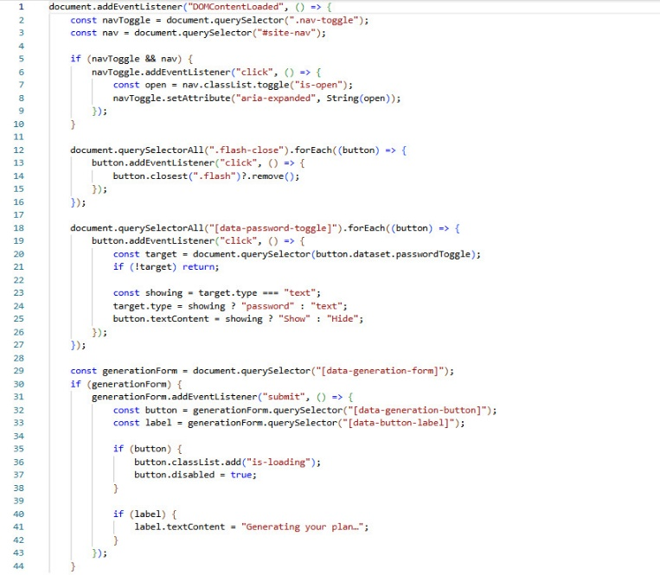

Nutrition/Recovery tip generation route

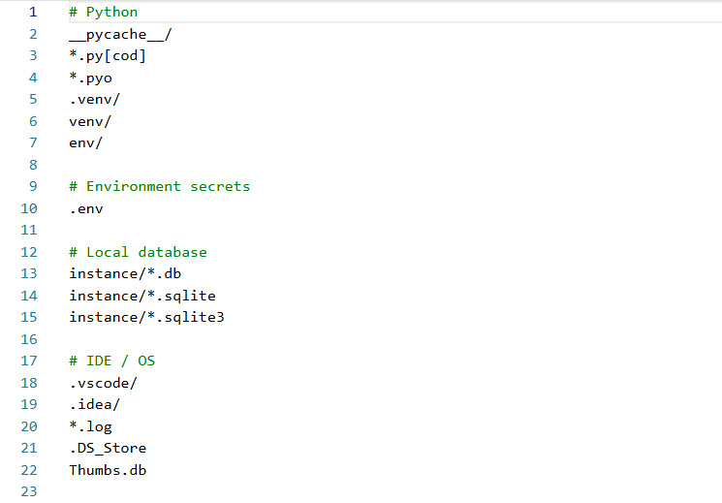
Description:This .gitignore file tells Git which files to leave out of version control. It ignores Python byproducts such as __pycache__/, compiled files (*.pyc, *.pyo) and virtual environments (.venv/, venv/, env/). It also protects the .env file, which holds secrets like API keys and passwords. Local SQLite databases in the instance/ folder are excluded so personal or test data isn't committed. Finally, it skips editor and OS clutter, including .vscode/, .idea/, log files, .DS_Store and Thumbs.db, which keeps the repository clean and secure.
The instance/ folder is the default location for Flask's local database, which is why I called it a Flask project. Want a shorter one-line version

Milestone 4. Frontend Development
Milestone 4 is focused on building a user-friendly, visually organized interface for FitBuddy, the AI-powered workout generator. This involves creating responsive and interactive web pages using HTML, CSS, and Jinja2 templating. Each template is dynamically rendered through FastAPI, making it easy for users to submit their input, receive personalized plans, and provide feedback — while also giving administrators the ability to manage data effectively. This milestone ensures a smooth and engaging fitness-planning experience for all users.
Activity 4.1: Designing and Developing the User Interface
Setting Up the Base HTML Structure
● index.html was built as the main entry point for capturing user input.
● The form was designed to collect: username, user ID, age, weight, goal, and intensity.
● Each input field is clearly labeled and organized using semantic HTML.
● The interface incorporates a gym-themed background image, Google Fonts (Roboto), and bold typography to give it a clean, fitness-oriented feel.
● Navigation was kept minimal to keep users focused, with a clear flow from input to output.
Designing a Responsive Layout Using CSS
● CSS styling was embedded directly within each HTML file.
● Flexbox was used to center content both vertically and horizontally.
● Media queries were added to ensure the layout adapts well to mobile screens.
● Buttons maintain consistent styling and include hover effects.
● Input fields and result sections feature adequate padding, subtle shadows, and rounded corners for a modern appearance.
● The color scheme was chosen to maximize readability against a dark background.
Creating Separate Pages for Each Core Functionality
Three Jinja2-powered HTML templates were built under /templates:
● index.html – A form for entering fitness goal, intensity, and basic personal details.
● result.html – Displays the AI-generated 7-day workout plan and nutrition tip, and includes an option for user feedback.
● all_users.html – An admin panel for viewing and deleting users, and reviewing both original and updated plans.
The templates are built in a modular fashion, allowing for smooth transitions as users move between steps.
Forms are submitted to specific FastAPI endpoints via POST methods

Milestone 5: Deployment

At this stage, the focus shifts to deploying the FitBuddy application on a local system using FastAPI and Uvicorn. The application relies on HTML templates rendered through Jinja2, along with AI services powered by Gemini. This milestone ensures that all environment dependencies are correctly installed and that the app runs smoothly on a local server, laying the groundwork for future deployment on cloud platforms.

Activity 5.1: Preparing the Application for Local Deployment

Setting Up a Virtual Environment

● A virtual environment was created to manage dependencies and keep the FitBuddy project isolated from other environments.
● Once activated, all required dependencies listed in the requirements.txt file — including FastAPI, Uvicorn, SQLAlchemy, and the Google Generative AI SDK — were installed.

python -m venv venv

source venv/bin/activate # On Windows: venv\Scripts\activate

pip install -r requirements.txt

Configuring Environment Variables

● Environment variables are used to store sensitive information, such as the Gemini API key.
● These variables can either be set directly in the terminal or added to a .env file, which is loaded into the application using python-dotenv.

GOOGLE_API_KEY=your_gemini_api_key_here

Frontend-Backend Rendering via Jinja2

All user interactions are supported through Jinja2-rendered templates:

● index.html – Collects user input
● result.html – Displays the AI-generated plan
● all_users.html – Lists all user records for the admin view

Activity 5.2: Testing and Verifying Local Deployment
Accessing the Application Locally
To begin, the FastAPI development server needs to be started using the command uvicorn main:app --reload. Once the server is up and running, the application can be accessed through any web browser by navigating to the local host address provided in the terminal output. This loads the main user interface, where users can enter their details and generate personalized fitness plans. In addition, FastAPI's interactive API documentation is available at the same local address with /docs appended to it, allowing developers to explore and test the available endpoints directly.

Exploring Website’s web pages:

Home page:
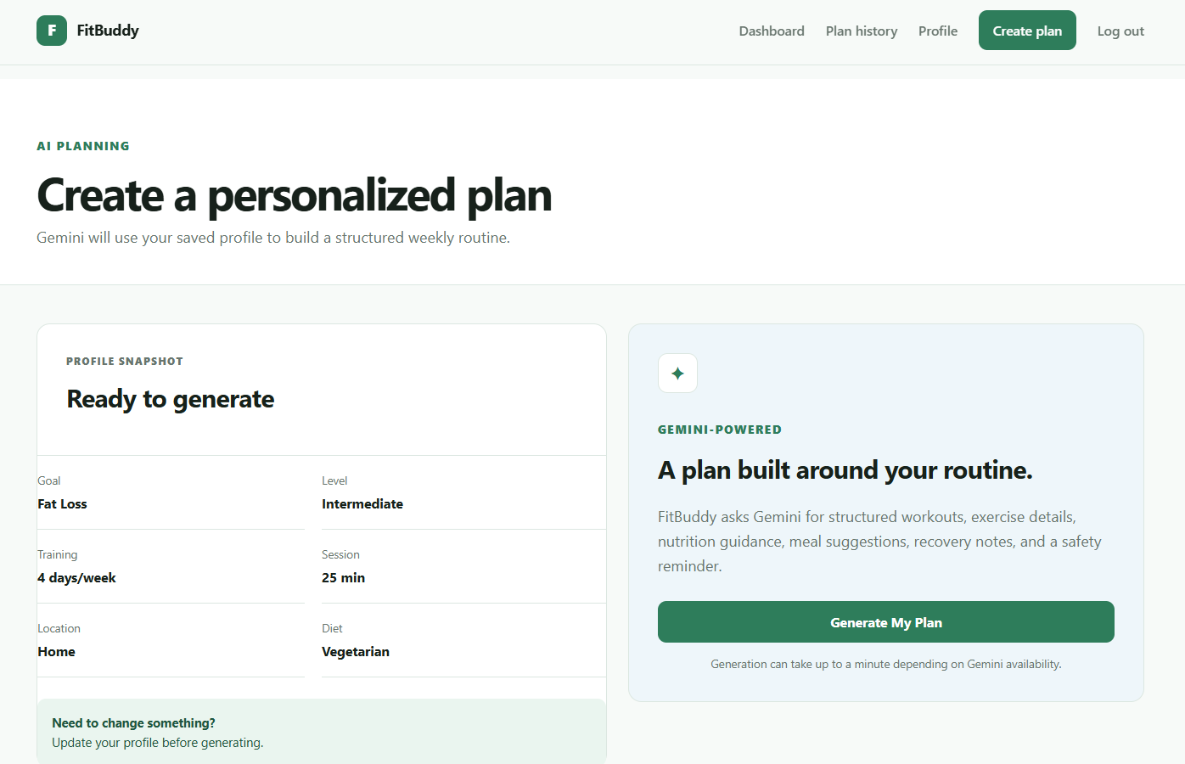

Description
The homepage of FitBuddy – AI Workout Generator offers a clean, engaging interface designed to give users a seamless experience when seeking personalized fitness plans. A form displayed prominently at the center of the page allows users to enter key details, including:
● Name
● User ID
● Age
● Weight (kg)
● Fitness Goal (e.g., weight loss, flexibility)
● Workout Intensity (Low, Medium, High)
After entering this information, users can click the "Generate Plan" button, which triggers the AI-powered backend to create a customized workout and nutrition plan based on their goals and fitness profile. The background image, featuring an active individual, reinforces the fitness-focused theme of the application and helps motivate users to take charge of their health journey.
This intuitive design ensures that users of any experience level can get started quickly and with minimal effort.
Personalized workout generation page:
User Information:
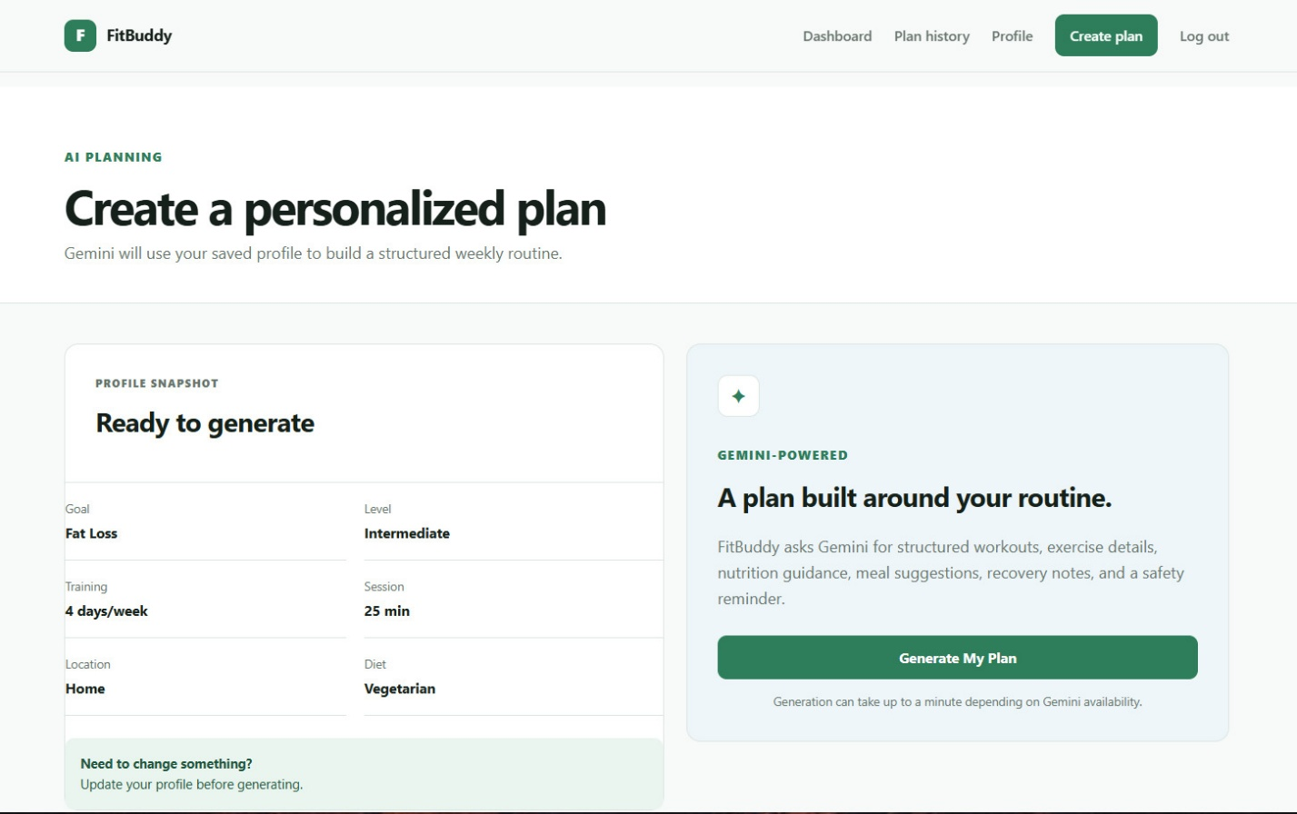
Description
Once the user submits their details, the application redirects to a personalized workout plan page. This page displays a summary of the information the user entered, including their Name, User ID, Age, Weight, Fitness Goal, and Selected Intensity. This personalized display helps users feel acknowledged and also guides the AI engine in generating workout recommendations that are specifically tailored to their fitness journey.

Workout Plan:
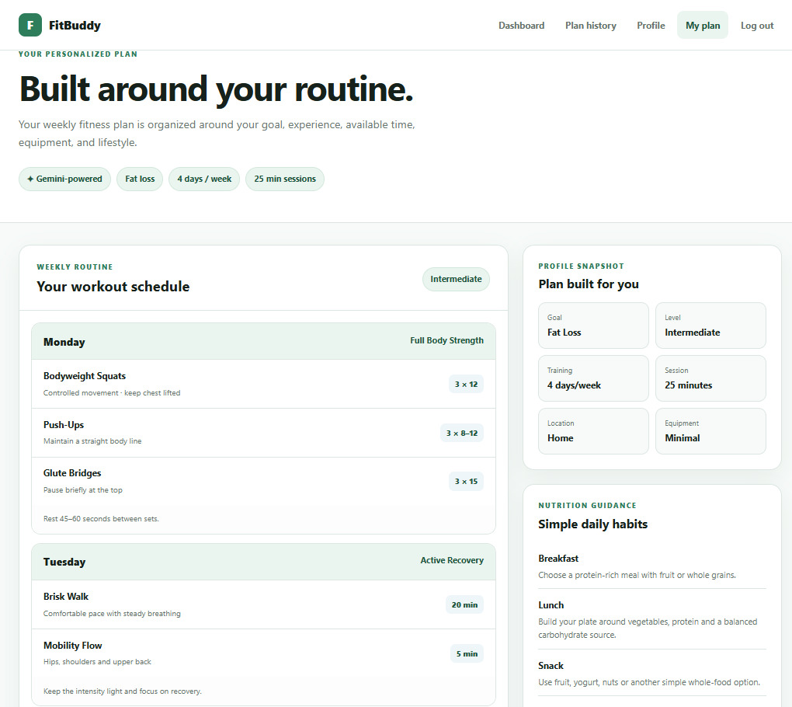
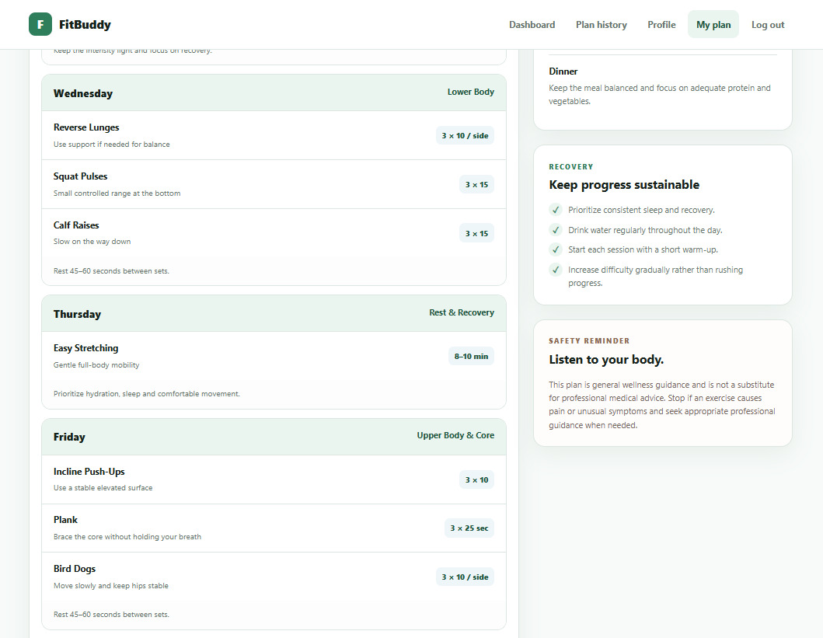
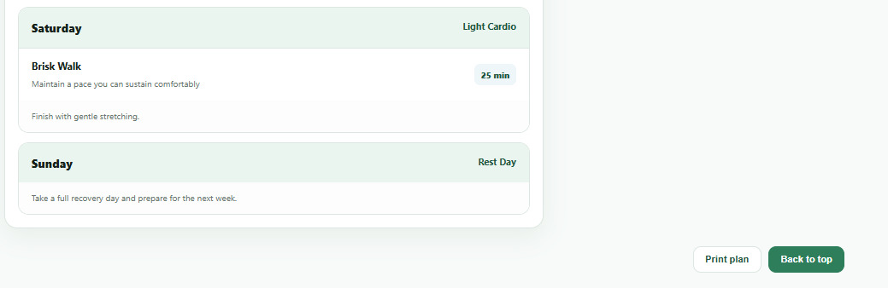

Description
FitBuddy generates a personalized, day-by-day workout plan based on the user's fitness goal, experience level, and preferred workout schedule. On the result page, the workout section outlines each day with a specific focus — such as full body, upper or lower body, cardio, core strength, or flexibility. For every workout day, a curated list of exercises is provided, including the exercise name, the number of sets and repetitions (or duration), and suggested rest intervals. The plan is designed with variety and structured progression to keep workouts both engaging and effective. Basic warm-up and cool-down guidance may also be included to support safe, well-rounded training. Overall, this section aims to provide a goal-oriented, easy-to-follow workout schedule that encourages consistency and progress.

Nutrition Tip:
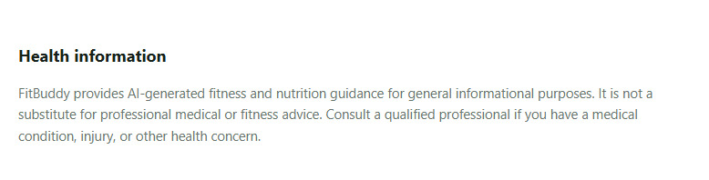
Description
The Nutrition Tip section in FitBuddy offers users concise, practical dietary advice that complements their workout plans. It highlights the importance of including protein in every meal, suggesting sources such as chicken, fish, beans, or Greek yogurt. The tip explains how protein supports muscle building, promotes satiety, and aids metabolic function — all of which play a key role in both fat loss and muscle gain. This section is designed to reinforce healthy eating habits that align with the user's fitness goals.

Plan Feedback: Helping Shape Your Next Fitness Routine
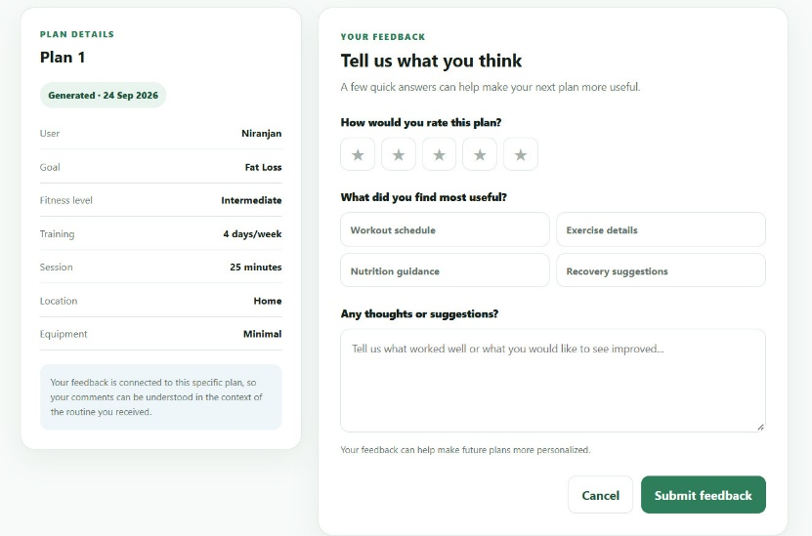
Description
This screen lets users give feedback on a personalized fitness plan generated on 24 Sep 2026. The plan, built for Niranjan, targets fat loss at an intermediate level, with four 25-minute home workouts a week using minimal equipment. Users can rate the plan from one to five stars, pick what they found most useful (workout schedule, exercise details, nutrition guidance, or recovery suggestions), and add written thoughts. Because the feedback is tied to this specific plan, comments are understood in the context of the routine received, which helps make future plans more personalized.
Once the plan has been updated, a confirmation message is displayed to the user.


Personalized AI-Generated Fat Loss & Fitness Plan Dashboard:
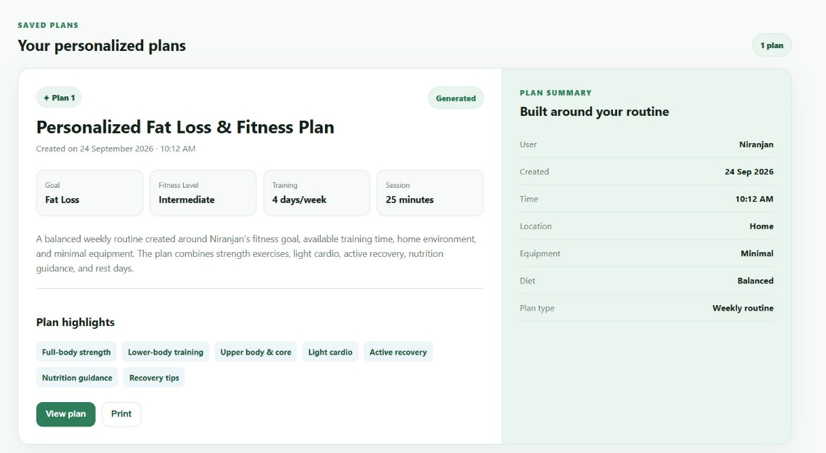
Description
This screenshot shows the “Saved Plans” section of the FitBuddy fitness application, displaying a personalized fitness plan titled “Personalized Fat Loss & Fitness Plan” created on 24 September 2026 at 10:12 AM for the user. The plan is categorized as Plan 1 and marked as Generated, indicating that it was automatically created by the system. The main specifications include a Fat Loss goal, Intermediate fitness level, 4 training days per week, and 25-minute sessions. The plan provides a balanced weekly routine designed for a home environment with minimal equipment, combining full-body strength training, light cardio, active recovery, nutrition guidance, and rest days. The Plan Summary panel displays additional details such as Location: Home, Equipment: Minimal, Diet: Balanced, and Plan Type: Weekly Routine. The Plan Highlights section lists important components including full-body strength, lower-body training, upper body and core exercises, light cardio, active recovery, nutrition guidance, and recovery tips. Users can also select “View Plan” to see the complete routine or “Print” to obtain a printable version of the generated plan.

Conclusion

FitBuddy – AI Fitness Plan Generator using Gemini Models is designed as a personalized, user-friendly fitness assistance platform that combines web technology, database management, and generative artificial intelligence into a single application. The primary purpose of the system is to overcome the limitations of generic fitness plans by considering the individual requirements, preferences, goals, and lifestyle information of each user. Instead of providing the same routine to everyone, FitBuddy uses the information entered by the user to generate a more relevant and structured fitness plan.

The application provides a complete user journey beginning with registration and login. Secure authentication allows users to access their own fitness information and generated plans. After logging in, users can create and maintain their fitness profile by providing details such as age, gender, height, weight, fitness level, fitness goal, activity level, workout frequency, session duration, workout location, available equipment, diet preference, and additional notes. These details form the foundation of the personalized planning process.

One of the major features of FitBuddy is its AI-powered plan generation system. The application integrates the Google Gemini model through a server-side API connection. The collected fitness-profile information is combined with carefully designed prompts and provided to the AI model. Prompt engineering is used to guide the model toward generating useful and structured fitness information rather than a simple conversational response. The system can request structured JSON output, which makes the generated information easier for the application to validate, process, store, and display.

The generated plan provides a practical weekly fitness structure containing workout schedules, exercises, sets, repetitions, session durations, recovery recommendations, nutrition guidance, and safety reminders. The plan is presented through a clean and understandable interface so that users can easily follow their recommended routine. The application also provides plan history functionality, allowing users to review previously generated plans and maintain a record of their fitness-planning journey. Feedback functionality further supports user interaction by allowing users to provide ratings, comments, and suggestions about their personalized plans.

From the technical perspective, FitBuddy demonstrates the integration of multiple technologies within a modular software architecture. Python and Flask provide the backend application framework and routing structure, while HTML5, CSS3, JavaScript, and Jinja2 templates are used to create the responsive user interface. SQLite provides persistent data storage, and SQLAlchemy acts as the Object-Relational Mapping layer for managing database operations. The project separates application routes, database models, AI services, templates, and static resources, making the system easier to understand, maintain, and extend.

Security is also an important part of the application. User passwords can be protected through password hashing, authentication and authorization checks help restrict access to user-specific information, and sensitive configuration such as API credentials can be maintained through environment variables. CSRF protection, safe database queries, and ownership validation further contribute to a more secure application structure.

Overall, FitBuddy demonstrates how artificial intelligence can be combined with conventional web-development technologies to create a personalized fitness-support system. The project does not simply focus on generating AI content; it demonstrates a complete workflow involving user registration, profile creation, personalized input collection, AI processing, structured output generation, database storage, plan presentation, history management, and feedback collection.

The project can also be extended in the future with additional capabilities such as progress tracking, exercise demonstrations, wearable-device integration, improved nutrition personalization, plan adaptation based on user feedback, advanced analytics, and continuous plan updates. These improvements could make the system more interactive and responsive to changes in a user's fitness journey.

In conclusion, FitBuddy successfully brings together Flask-based web development, database management, prompt engineering, structured AI generation, and personalized user interaction into one integrated fitness application. Its overall approach demonstrates the practical use of generative AI for creating individualized fitness guidance while maintaining a simple and accessible user experience. The project provides a strong foundation for further development into a more comprehensive AI-assisted wellness platform

